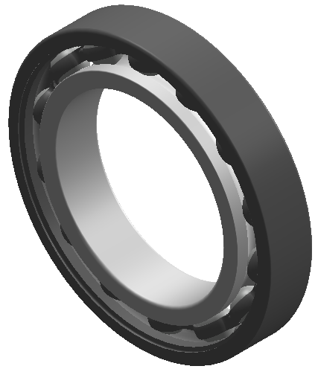 Angular contact ball bearing diagram

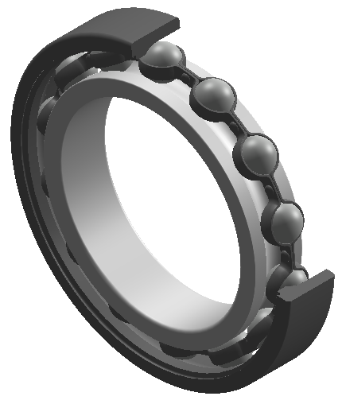 Angular contact ball bearing section view

TPI bearing model form
Type No. | d | D | B
708C | 8 | 22 | 7
7000C | 10 | 26 | 8
7001C | 12 | 28 | 8
7002C | 15 | 32 | 9
7003C | 17 | 35 | 10
7004C | 20 | 42 | 12
7005C | 25 | 47 | 12
7006C | 30 | 55 | 13
7007C | 35 | 62 | 14
7008C | 40 | 68 | 15
7009C | 45 | 75 | 16
7010C | 50 | 80 | 16
7011C | 55 | 90 | 18
7012C | 60 | 95 | 18
7013C | 65 | 100 | 18
7014C | 70 | 110 | 20
7015C | 75 | 115 | 20
7016C | 80 | 125 | 22
7017C | 85 | 130 | 22
7018C | 90 | 140 | 24
7019C | 95 | 145 | 24
7020C | 100 | 150 | 24
7000AD | 10 | 26 | 8
7001AD | 12 | 28 | 8
7002AD | 15 | 32 | 9
7003AD | 17 | 35 | 10
7004AD | 20 | 42 | 12
7005AD | 25 | 47 | 12
7006AD | 30 | 55 | 13
7007AD | 35 | 62 | 14
7008AD | 40 | 68 | 15
7009AD | 45 | 75 | 16
7010AD | 50 | 80 | 16
7011AD | 55 | 90 | 18
7012AD | 60 | 95 | 18
7013AD | 65 | 100 | 18
7014AD | 70 | 110 | 20
7015AD | 75 | 115 | 20
7016AD | 80 | 125 | 22
7017AD | 85 | 130 | 22
7018AD | 90 | 140 | 24
7019AD | 95 | 145 | 24
7020AD | 100 | 150 | 24
7200C | 10 | 30 | 9
7201C | 12 | 32 | 10
7202C | 15 | 35 | 11
7203C | 17 | 40 | 12
7204C | 20 | 47 | 14
7205C | 25 | 52 | 15
7206C | 30 | 62 | 16
7207C | 35 | 72 | 17
7208C | 40 | 80 | 18
7209C | 45 | 85 | 19
7210C | 50 | 90 | 20
7211C | 55 | 100 | 21
7212C | 60 | 110 | 22
7213C | 65 | 120 | 23
7214C | 70 | 125 | 24
7215C | 75 | 130 | 25
7216C | 80 | 140 | 26
7217C | 85 | 150 | 28
7218C | 90 | 160 | 30
7219C | 95 | 170 | 32
7220C | 100 | 180 | 34
706A | 6 | 17 | 6
708A | 8 | 22 | 7
7000A | 10 | 26 | 8
7001A | 12 | 28 | 8
7002A | 15 | 32 | 9
7003A | 17 | 35 | 10
7004A | 20 | 42 | 12
7005A | 25 | 47 | 12
7006A | 30 | 55 | 13
7007A | 35 | 62 | 14
7008A | 40 | 68 | 15
7009A | 45 | 75 | 16
7010A | 50 | 80 | 16
7200A | 10 | 30 | 9
7201A | 12 | 32 | 9
7202A | 15 | 35 | 11
7203A | 17 | 40 | 12
7204A | 20 | 47 | 14
7205A | 25 | 52 | 15
7206A | 30 | 62 | 16
7207A | 35 | 72 | 17
7208A | 40 | 80 | 18
7209A | 45 | 85 | 19
7210A | 50 | 90 | 20
7207AD | 35 | 72 | 17
7208AD | 40 | 80 | 18
7210AD | 50 | 90 | 20
BT020ADB | 100 | 150 | 45
BT020BDB | 100 | 150 | 45
HS000CE1 | 10 | 26 | 8
HS001CE1 | 12 | 28 | 8
HS002CE1 | 15 | 32 | 9
HS003CE1 | 17 | 35 | 10
HS004CE1 | 20 | 42 | 12
HS004CE1LLB | 20 | 42 | 12
HS005CE1 | 25 | 47 | 12
HS005C1LLB | 25 | 47 | 12
HS006CE1 | 30 | 55 | 13
HS006CE1LLB | 30 | 55 | 13
HS007CE1 | 35 | 62 | 14
HS007CE1LLB | 35 | 62 | 14
HS008CE1 | 40 | 68 | 15
HS008CE1LLB | 40 | 68 | 15
HS009CE1 | 45 | 75 | 16
HS009CE1LLB | 45 | 75 | 16
HS010CE1 | 50 | 80 | 16
HS010CE1LLB | 50 | 80 | 16
HS011CE1 | 55 | 90 | 18
HS011CE1LLB | 55 | 90 | 18
HS012CE1 | 60 | 95 | 18
HS012CE1LLB | 60 | 95 | 18
HS013CE1 | 65 | 100 | 18
HS013CE1LLB | 65 | 100 | 18
HS014CE1 | 70 | 110 | 20
HS014CE1LLB | 70 | 110 | 20
HS015CE1 | 75 | 115 | 20
HS016CE1 | 80 | 125 | 22
HS017CE1 | 85 | 130 | 22
HS018CE1 | 90 | 140 | 24
HS019CE1 | 95 | 145 | 24
HS020CE1 | 100 | 150 | 24

